In the Academic staff page a search bar is inserted to search by name.There is a tag icon, users can enable it and add research fields.The people who have publications of the relevant field are sorted out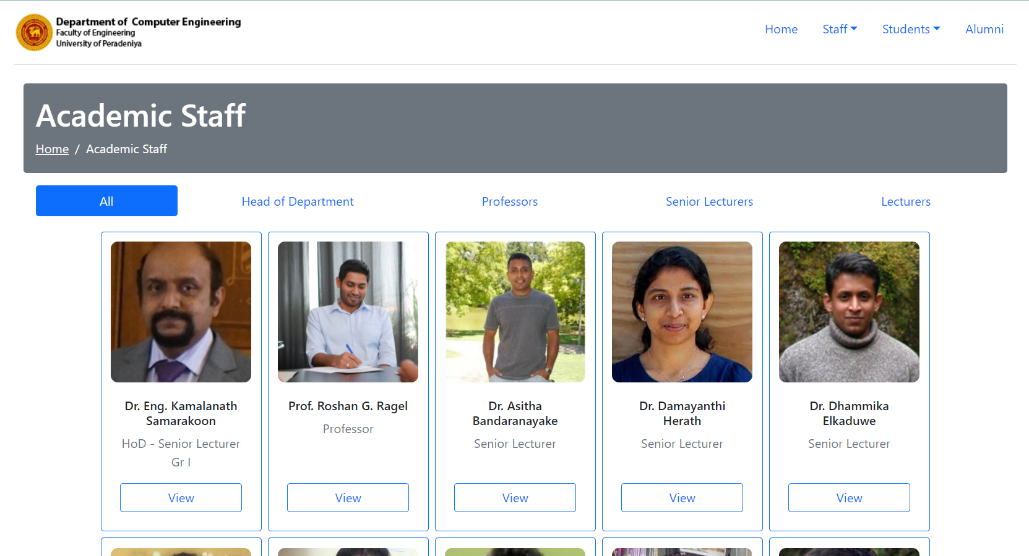

In the profiles page,tabs are added.

* Bio - Personal details and qualifications
* Publications - Researches outputs and Journal
* Grants-
* Teaching and supervision - Courses





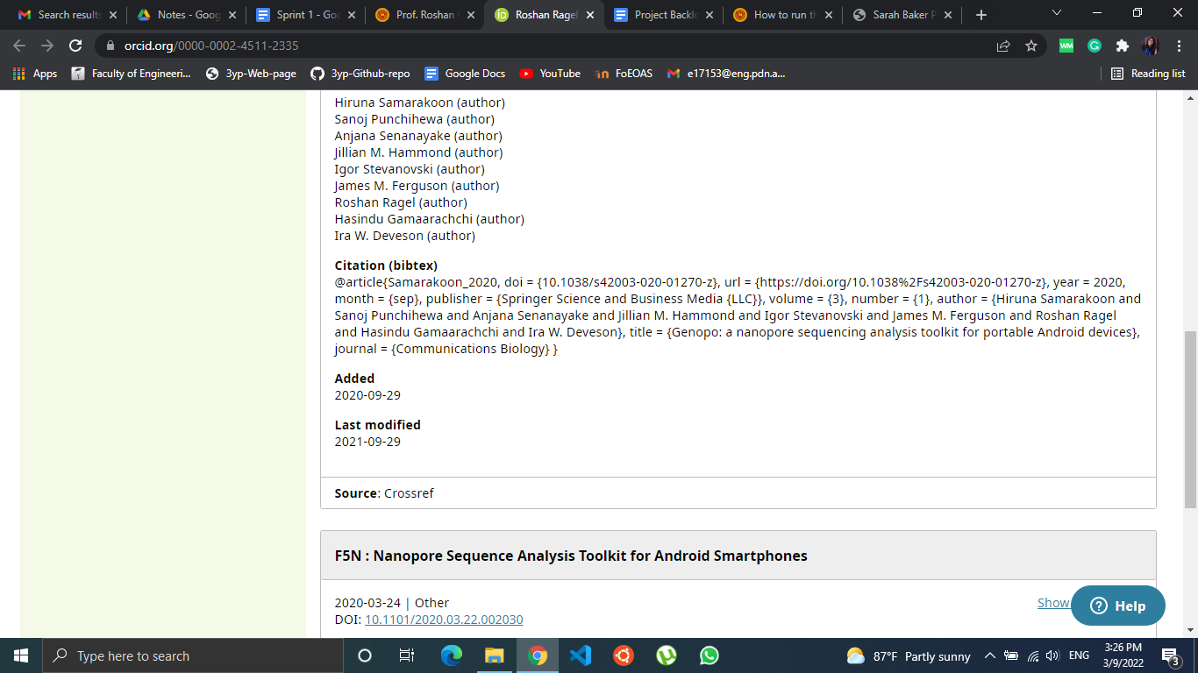

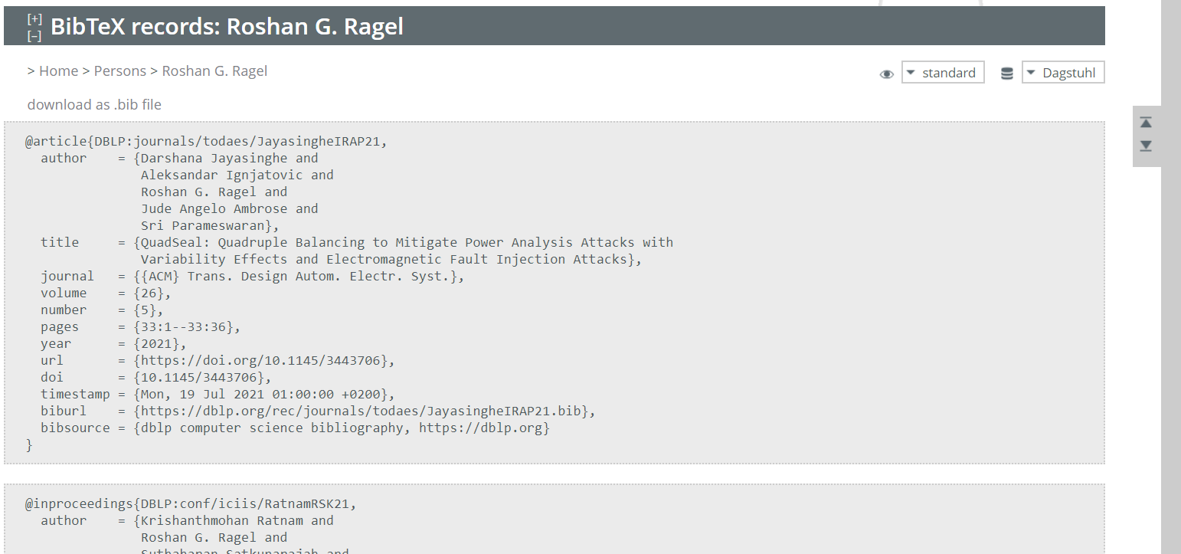

Publications :

* Type
* Title
* Year
* Authors
* Volume
* Number
* DOI
* Download